
East West University

Course Title: Statistics for Data Science
Course Code: CSE303

Section: 6
Semester: Spring-25
Submission Date: 10.05.2025
Group: 2
Topic: Assignment 1

Submitted To: Dipayan Bhadra

Submitted By:
Name | StudentID
Ayon Adhikary | 2022-3-60-137
Mahfuz Alam Imon | 2022-2-30-131
Shanghita Naha Sristy | 2022-3-60-311
Omar Faisal Shanto | 2022-2-60-125

Report on Wisconsin’s Survival Data

1. Research Problem
Objective: To develop a classification model that can predict whether a breast tumor is malignant or benign based on diagnostic measurements extracted from digitized images of a fine needle aspirate (FNA) of a breast mass.
Given the diagnostic nature and categorical outcome (Diagnosis: M = Malignant, B = Benign), the study is framed as a supervised classification problem, where algorithms like Logistic Regression, SVM.

At this point Exploratory Data Analysis can be performed for initial investigations on data, to discover patterns, to spot anomalies, to test hypothesis and to check assumptions with the help of summary statistics and graphical representations. The following sections represent EDA for our data set.

2. Data Description
The Breast Cancer Wisconsin Diagnostic Dataset consists of 569 instances and 32 columns, including one ID, one target variable (Diagnosis), and 30 real-valued input features derived from images.
Summary of Features:
- ID: Unique identifier
- Diagnosis: Target variable (M = Malignant, B = Benign)
- Radius, Texture, Perimeter, Area, Smoothness, etc.: Computed for the mean, standard error, and worst (mean of the three largest values) of each feature.
All features are numeric (ratio/interval) except for Diagnosis, which is nominal.

3. Data Cleaning
# Dataset dimension
df.shape # Output: (569, 32)
# Check for null values
df.isnull().sum()

We have 32 variables and 569 observations in our dataset. No Missing values were found in our dataset. Now we will make the boxplot to see the outliers in this dataset. 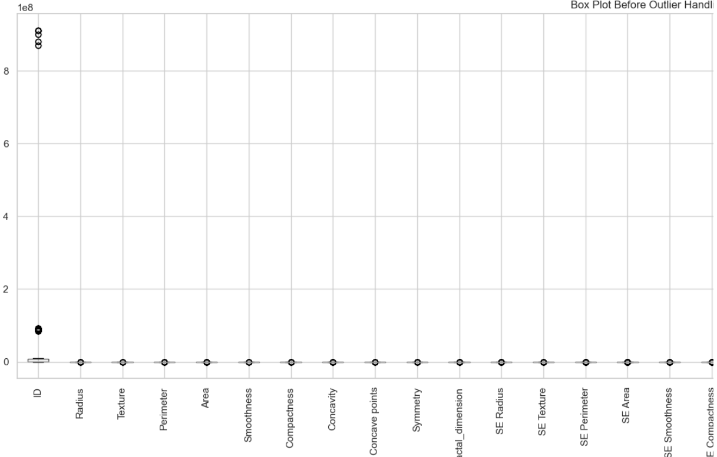
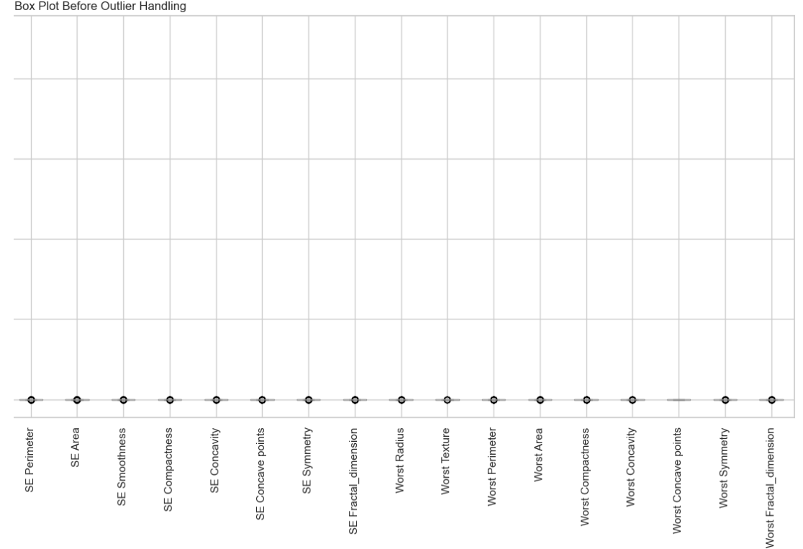

Figure 1 & 2: Boxplot of Breast_Cancer_Wisconsin_Assignment dataset.

The box plots suggest the presence of extreme outliers or inconsistent scaling, which is masking the distributions. To fix this, consider:
- Scaling/normalizing the data.
- Plotting individual box plots per feature.
- Using a log transformation or z-score method to rescale outliers.

4. Exploratory Data Analysis (EDA) :
4.1 Univariate Analysis:
a. Diagnosis
sns.countplot(x='Diagnosis', data=df)
- Malignant: ~37%
- Benign: ~63%
- Benign cases dominate the dataset, indicating class imbalance.

- Graphical Representations:

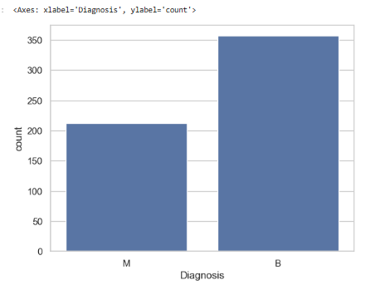

b. Radius Mean
sns.histplot(df['Radius'], kde=True)
- Appears slightly left-skewed, with higher radius often correlating with malignancy.

Graphical Representations:
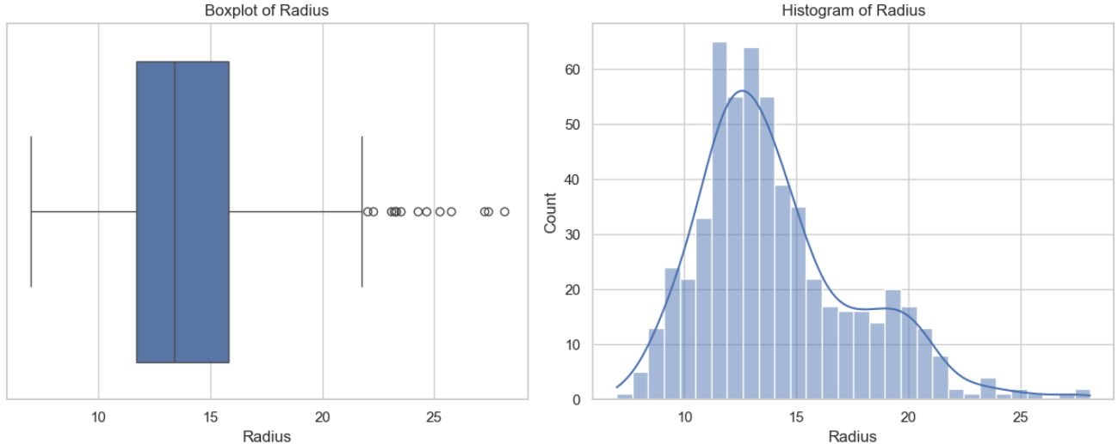

Figure 3 : Boxplot and Histogram of Radius
- The boxplot shows that malignant tumors generally have higher radius values compared to benign ones.
- The histogram reveals a slightly right-skewed distribution, with most tumors having a radius between 10 and 20.

c. Area Mean
sns.boxplot(x='Diagnosis', y='Area', data=df)
- Malignant tumors tend to have significantly larger areas than benign ones.

Graphical Representations:
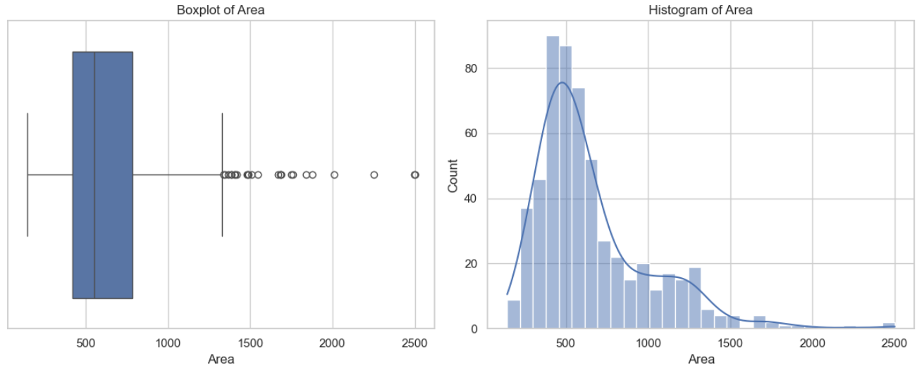
Figure 4 : Boxplot and Histogram of Area

- The boxplot shows that malignant areas generally have higher radius values compared to benign ones.
- The histogram reveals a slightly left-skewed distribution, with most area having a radius between 250 and 1000.

4.2 Bivariate Analysis
- sns.scatterplot(x='Radius', y='Area', hue='Diagnosis', data=df)
- Positive correlation observed.
- Malignant tumors usually appear in the upper-right quadrant (larger radius and area).

Graphical Representations:

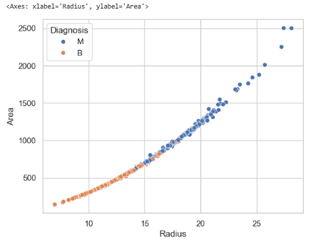

Figure 5 : Diagnosis

This scatter plot effectively separates benign and malignant tumors based on their radius and area. The graph indicates that larger tumors (in terms of radius and area) are more likely to be malignant, which is a valuable insight for classification in medical diagnostics.
b. Correlation Matrix:
- Strong correlation between:
  - Radius, Perimeter, Area, and Concavity.
  - Important for feature selection and dimensionality reduction (e.g., PCA).

- Graphical Representations:

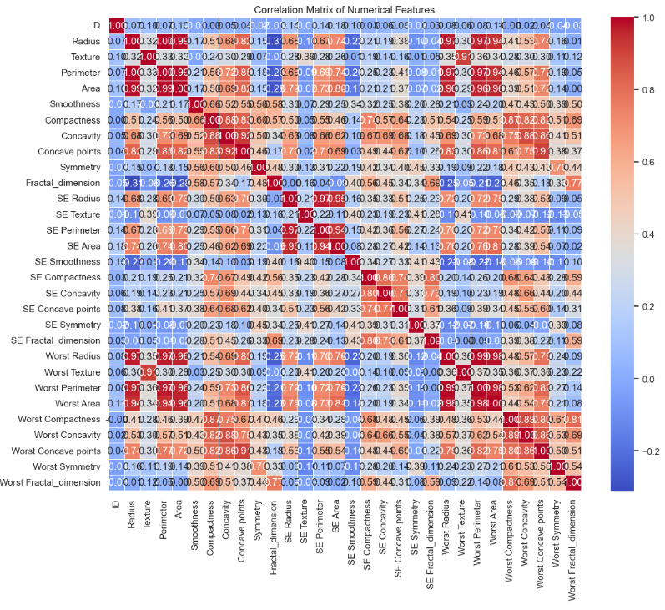
5. Summary Statistics :
Using df.describe() and grouping by diagnosis:

df.groupby('Diagnosis').mean()
- Malignant tumors tend to have higher:
  - Mean radius, area, perimeter
  - Standard error and worst values of concavity, compactness
- Benign tumors typically have lower variability and smaller cell size

6. Discussion
The EDA indicates clear distinctions between malignant and benign tumors based on several radiomic features. Particularly, attributes like Radius, Area, and Concavity show strong discriminatory power.
These insights can be used to feed into machine learning classification models. Feature scaling (e.g., Standard Scaler) may be applied due to the wide range of values.
Given the binary nature of the response and the well-structured features, algorithms like:
- Logistic Regression
- Random Forest
- Support Vector Machines (SVM)
are suitable for building predictive models.
7. Conclusion
This analysis demonstrates that the Breast Cancer Wisconsin dataset contains rich and meaningful patterns that can be used to accurately classify tumor types. With proper preprocessing and model selection, this dataset can support reliable diagnostics to aid early cancer detection.

